Database lab-7
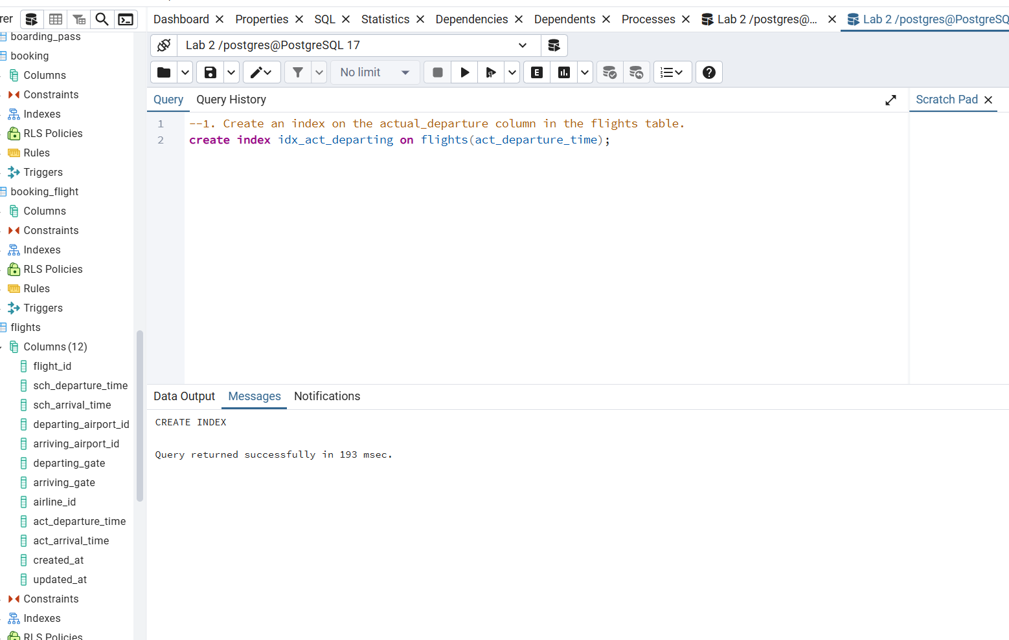
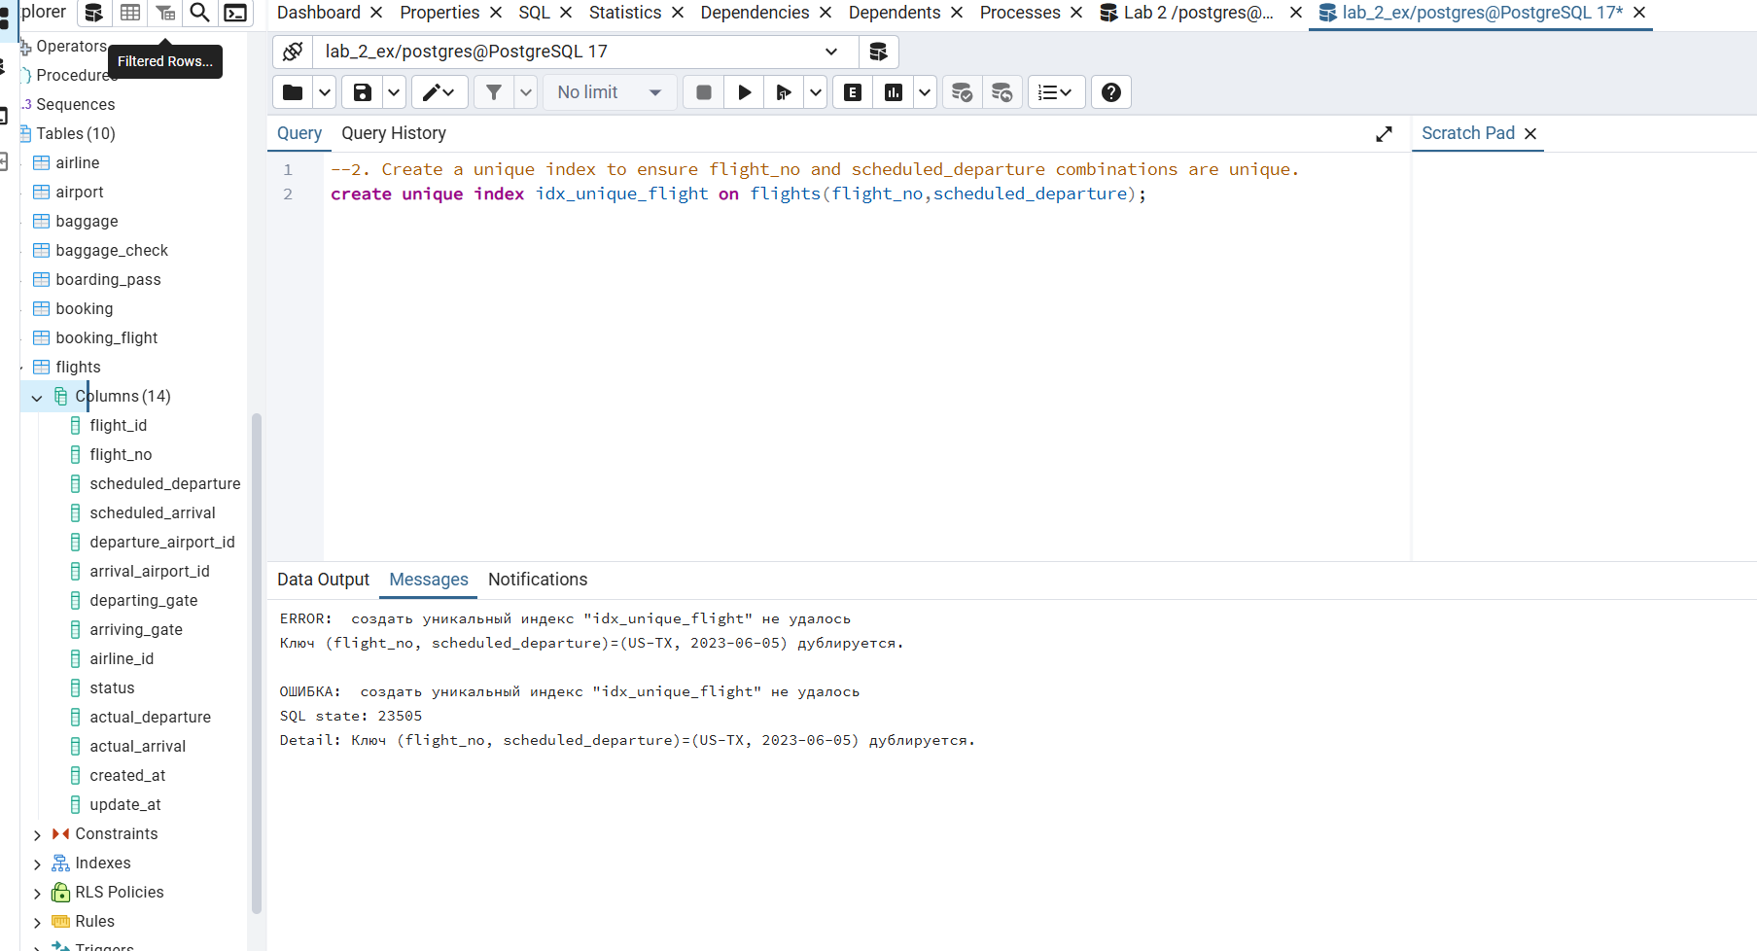
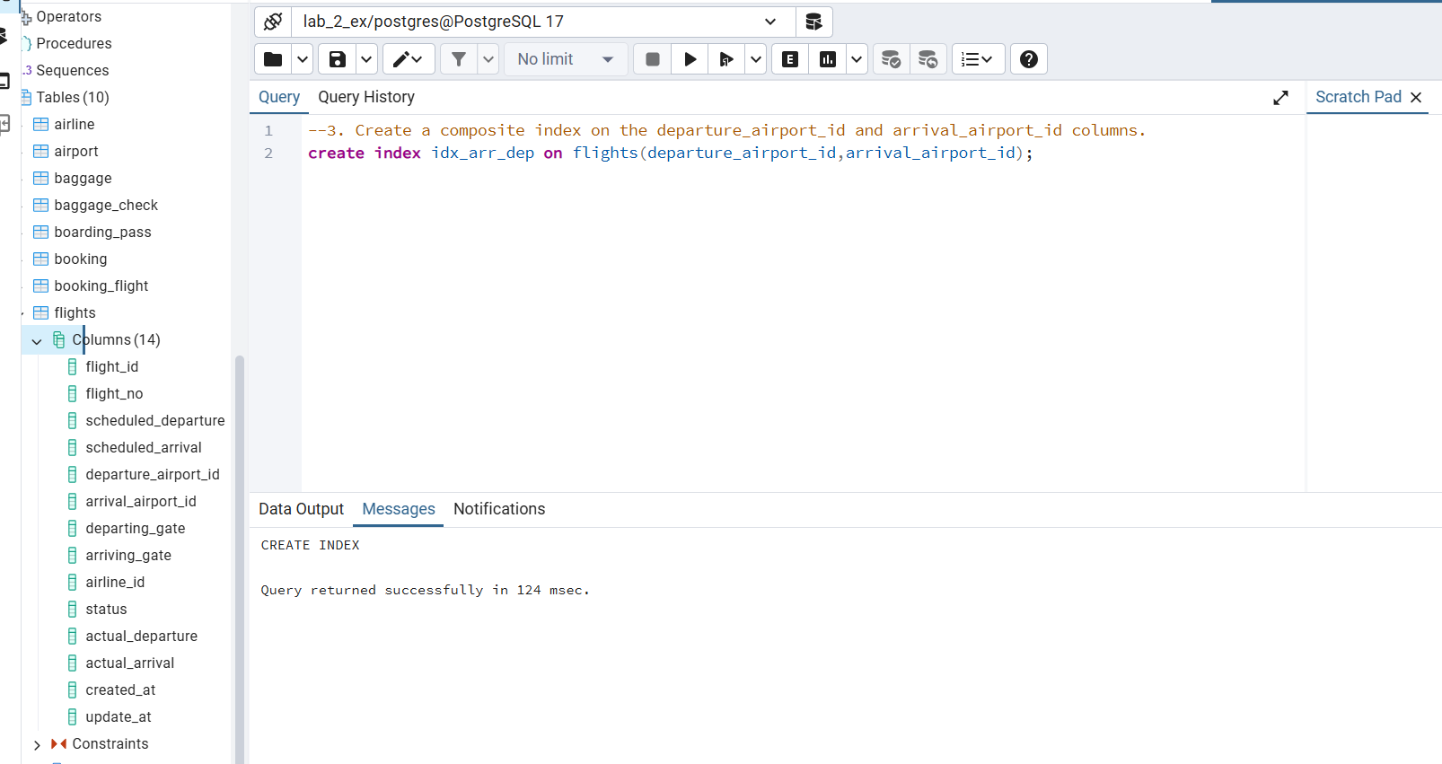

4 task without index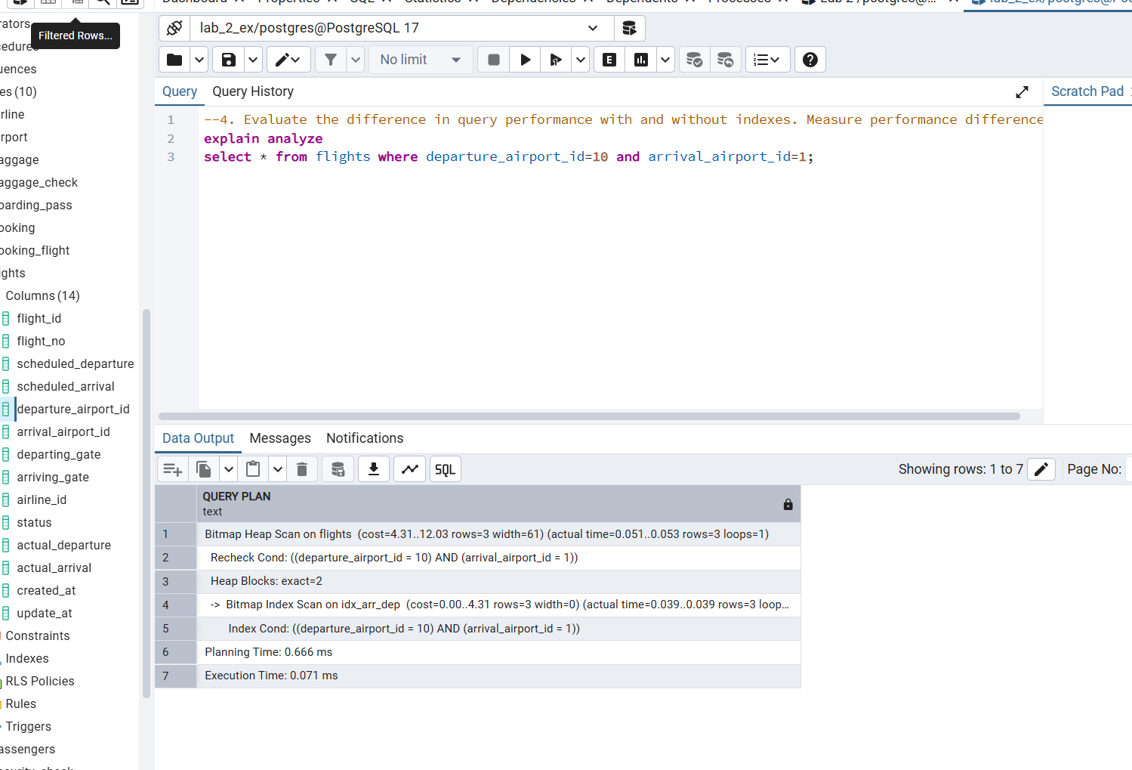
4 task with index
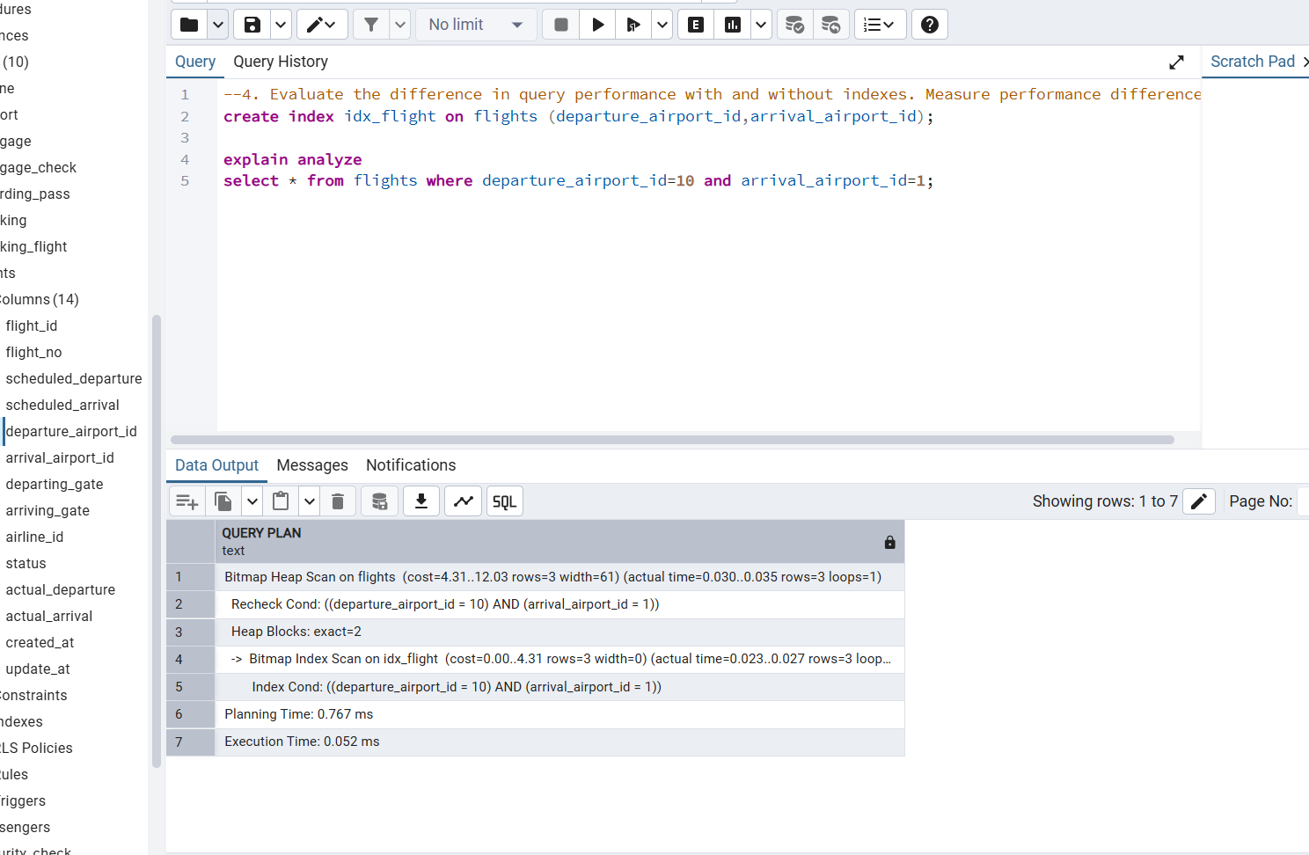
6 task 1part
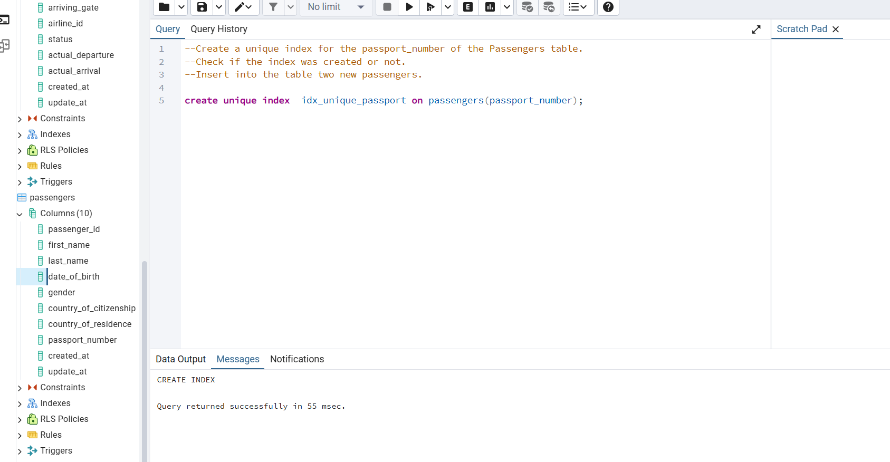
2part
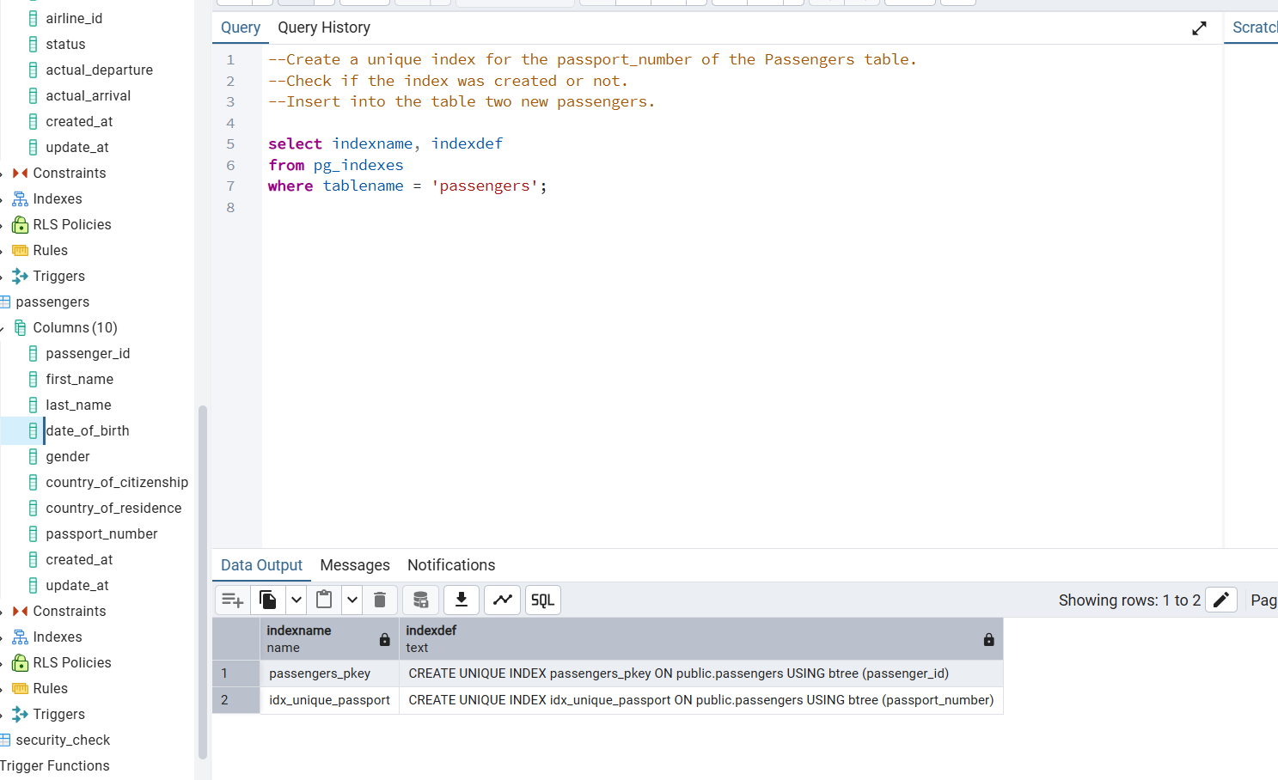
3 part
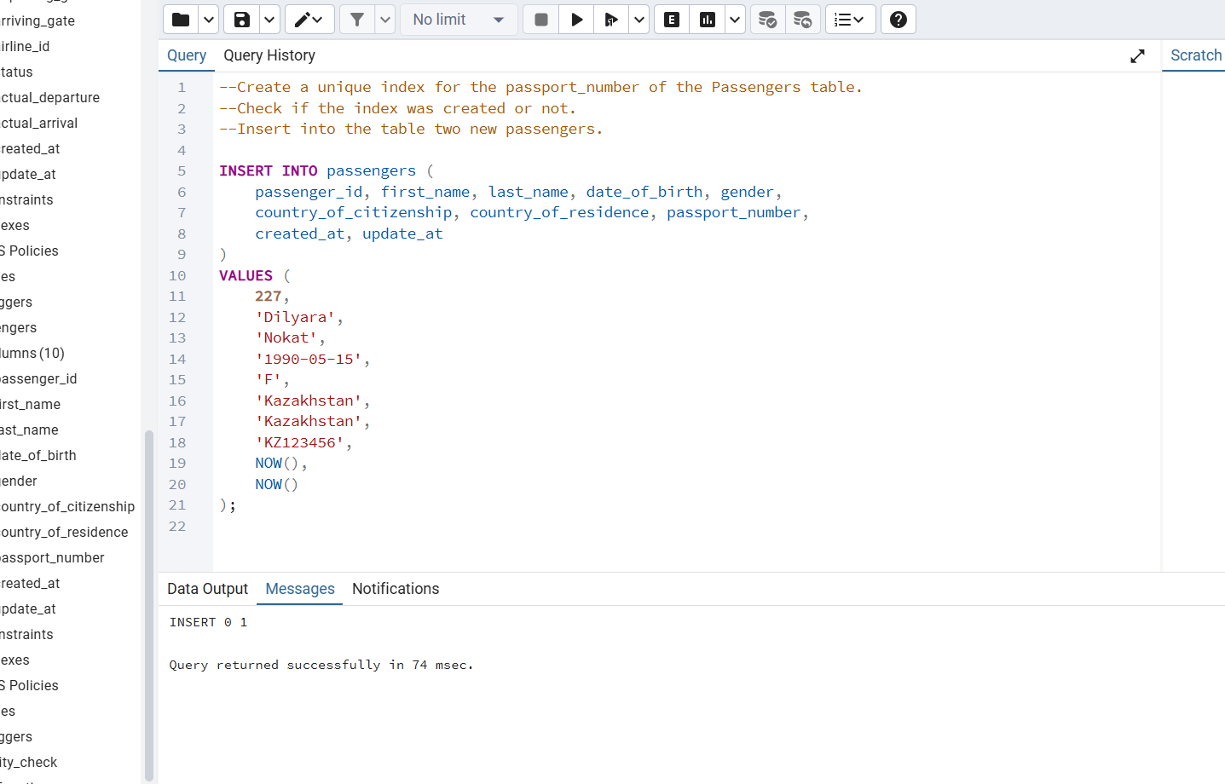
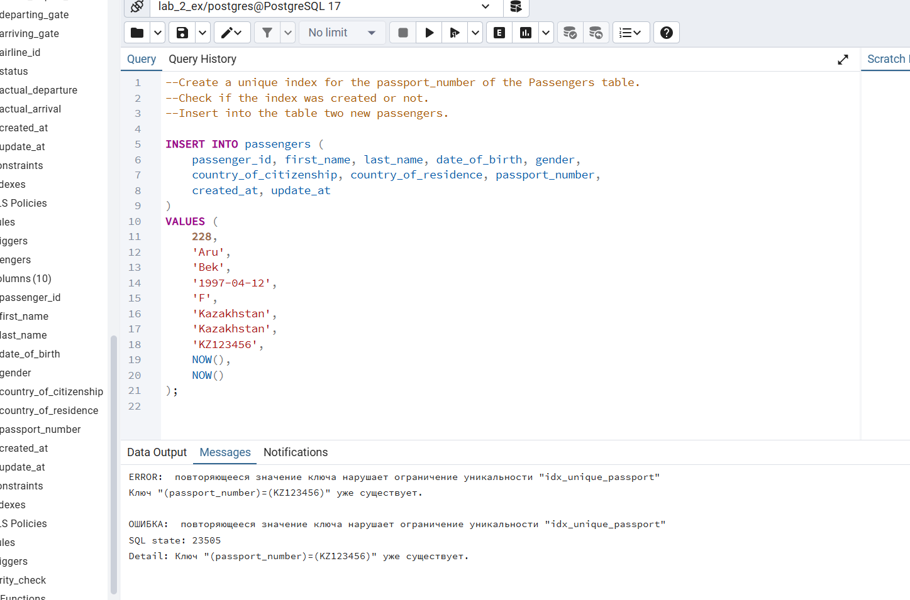

When I ran EXPLAIN ANALYZE, the output showed that PostgreSQL used an index scan on the flights table.This means the database used the created index to quickly find the rows matching the given departure_airport_id and arrival_airport_id, instead of scanning the whole table.As a result, the query executed faster, showing lower cost and execution time compared to when there was no index.

5 task
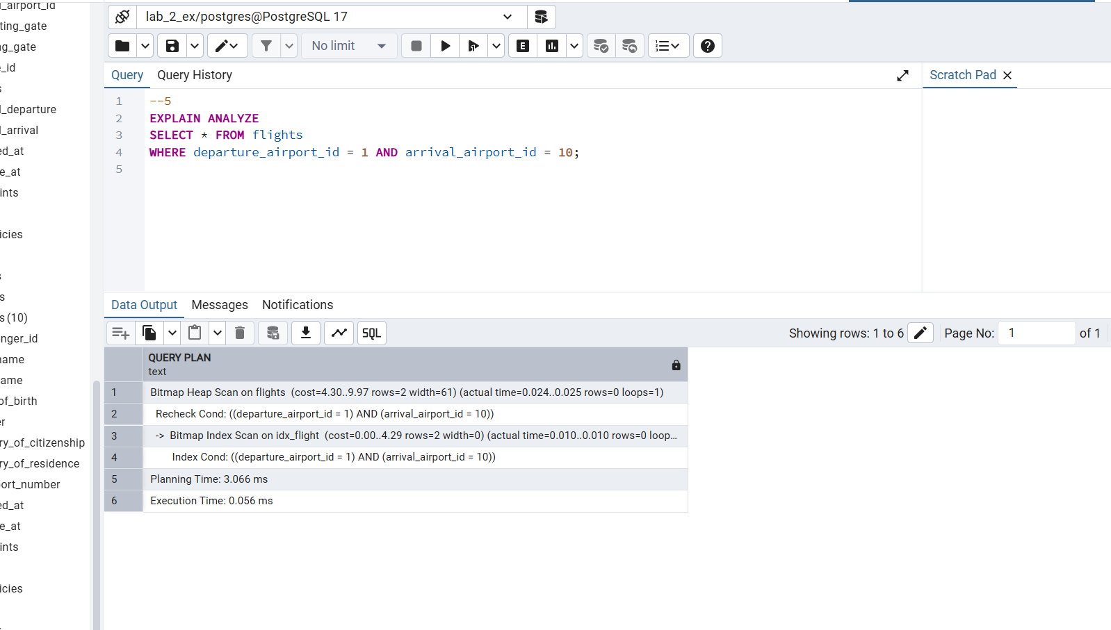
7 task
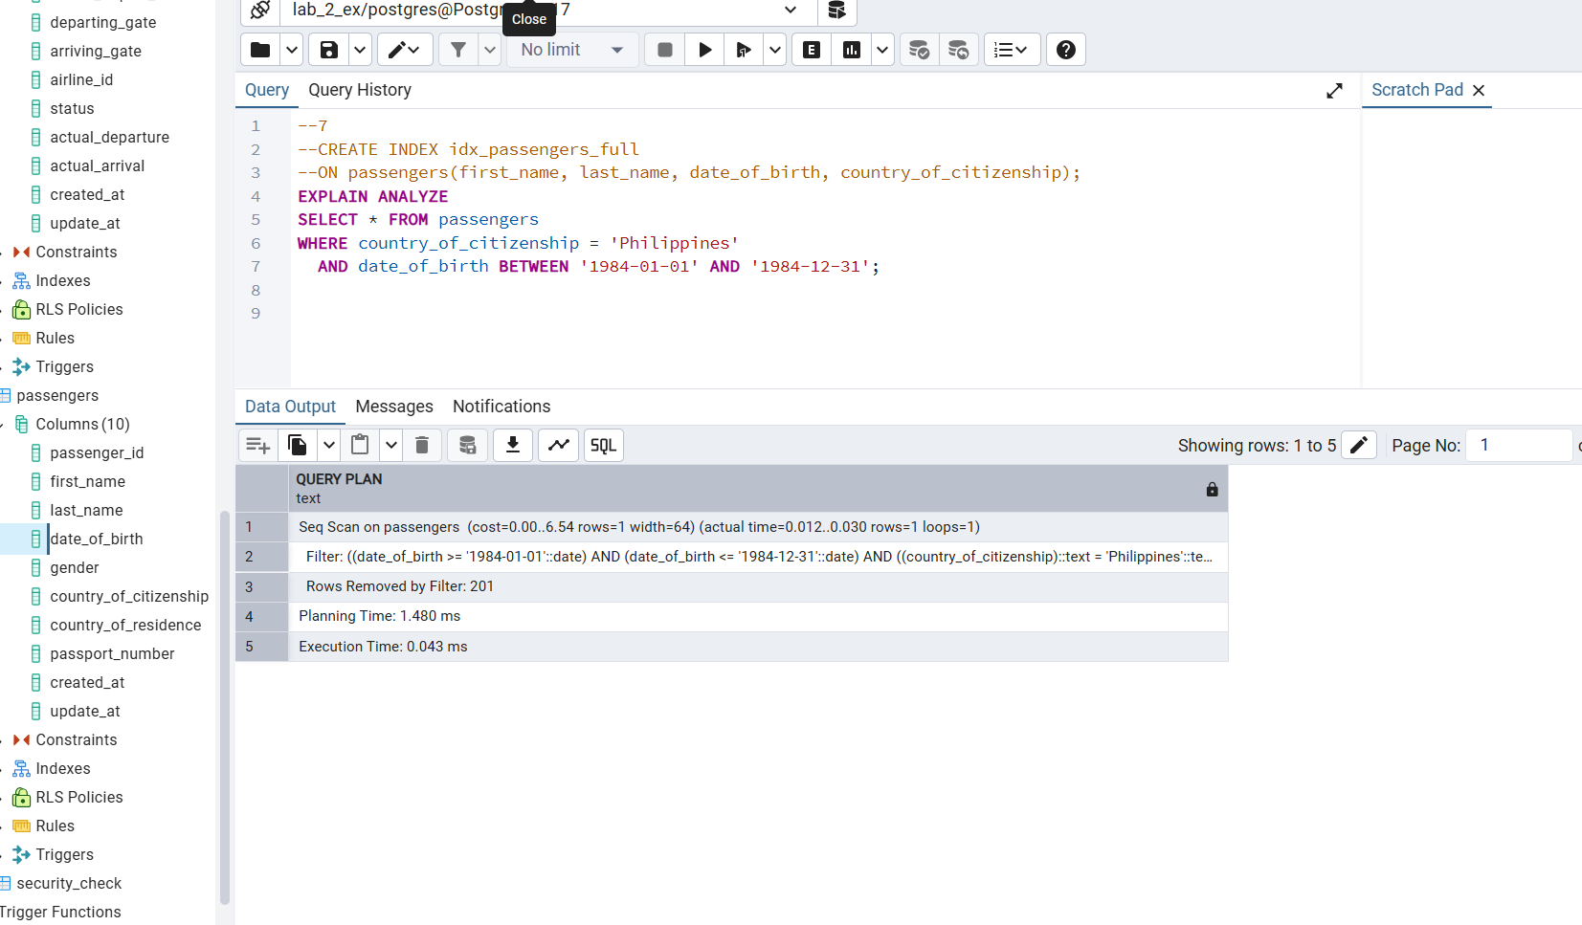
The query checks if PostgreSQL uses the index when filtering by date of birth and country.
If the output shows Index Scan, the index is used and improves performance. if it shows Seq Scan, the table is small and PostgreSQL decided that scanning all rows is faster.
8 task
